**Iteration 1**

Avg Loss: 0.019973102828551983

Avg Mae: 0.05858001947916787

Avg Val_Loss: 0.008738376445072735

Avg Val_Mae: 0.04303033328775702

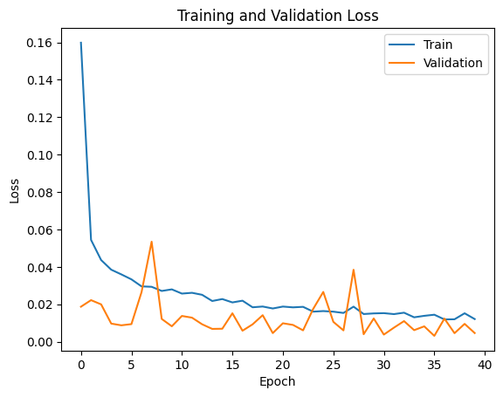

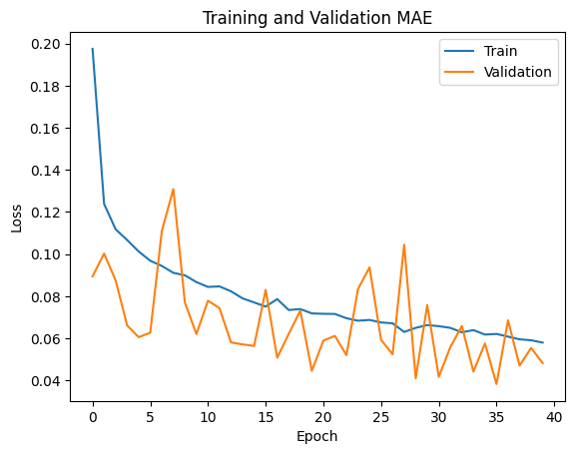

149/149 [==============================] - 1s 4ms/step

50/50 [==============================] - 0s 3ms/step

Training RRMSE: 0.004844132300036976

Validation RRMSE: 0.007241317527816495

Final Evaluation on Test Data

52/52 [==============================] - 0s 4ms/step - loss: 0.0013 - mae: 0.0218 - mape: 24.9852

[0.0012896278640255332, 0.02179494872689247, 24.985244750976562]

Loss:0.0012896278640255332

MAE: 0.02179494872689247

**Iteration 2**

**Avg Loss: 0.015231143607525154**

**Avg Mae: 0.05132614392787218**

**Avg Val_Loss: 0.004948590972344391**

**Avg Val_Mae: 0.03884640117175877**





**149/149 [==============================] - 1s 4ms/step**

**50/50 [==============================] - 0s 4ms/step**

**Training RRMSE: 0.004622610457373503**

**Validation RRMSE: 0.007091536266145533**

Final Evaluation on Test Data

**52/52 [==============================] - 0s 5ms/step - loss: 0.0012 - mae: 0.0225 - mape: 13.8613**

**[0.0011855250922963023, 0.02248528227210045, 13.8612642288208]**

**Loss:0.0011855250922963023**

**MAE: 0.02248528227210045**

**Iteration 3**

**Avg Loss: 0.01653156354886425**

**Avg Mae: 0.05421666625668021**

**Avg Val_Loss: 0.006237483155393206**

**Avg Val_Mae: 0.040290124276105094**





**149/149 [==============================] - 1s 4ms/step**

**50/50 [==============================] - 0s 3ms/step**

**Training RRMSE: 0.005318865743516049**

**Validation RRMSE: 0.009047961721064632**

Final Evaluation on Test Data

**52/52 [==============================] - 0s 3ms/step - loss: 0.0022 - mae: 0.0286 - mape: 33.7420**

**[0.0021607615053653717, 0.028569160029292107, 33.74197769165039]**

**LOSS:0.0021607615053653717**

**MAE: 0.028569160029292107**

**Iteration 4**

**Avg Loss: 0.02146031713599096**

**Avg Mae: 0.06342754901751228**

**Avg Val_Loss: 0.009176721902685646**

**Avg Val_Mae: 0.05007166123908499**





**149/149 [==============================] - 1s 3ms/step**

**50/50 [==============================] - 0s 3ms/step**

**Training RRMSE: 0.006235641833848726**

**Validation RRMSE: 0.010589945609585243**

Final Evaluation on Test Data

**52/52 [==============================] - 0s 3ms/step - loss: 0.0027 - mae: 0.0339 - mape: 33.4993**

**[0.0026915790513157845, 0.033929742872714996, 33.49934768676758]**

**LOSS: 0.0026915790513157845**

**MAE:0.033929742872714996**

**Iteration 5**

**Avg Loss: 0.01865568236363205**

**Avg Mae: 0.05656307303544247**

**Avg Val_Loss: 0.008054468879532633**

**Avg Val_Mae: 0.04231132352442452**





**149/149 [==============================] - 1s 3ms/step**

**50/50 [==============================] - 0s 3ms/step**

**Training RRMSE: 0.005095874690962178**

**Validation RRMSE: 0.00698698109346209**

Final Evaluation on Test Data

**52/52 [==============================] - 0s 3ms/step - loss: 0.0010 - mae: 0.0209 - mape: 25.0100**

**[0.001039819442667067, 0.020912693813443184, 25.009990692138672]**

**LOSS:0.001039819442667067**

**MAE:0.020912693813443184**

**Iteration 6**

**Avg Loss: 0.016488351337047236**

**Avg Mae: 0.05416504203370123**

**Avg Val_Loss: 0.004115476837438165**

**Avg Val_Mae: 0.03648954144481457**





**149/149 [==============================] - 1s 3ms/step**

**50/50 [==============================] - 0s 3ms/step**

**Training RRMSE: 0.006541907189377964**

**Validation RRMSE: 0.007375222076923654**

Final Evaluation on Test Data

**52/52 [==============================] - 0s 3ms/step - loss: 0.0011 - mae: 0.0215 - mape: 18.3206**

**[0.0011221887543797493, 0.021460043266415596, 18.320579528808594]**

**LOSS:0.001122188754379749**

**MAE:0.021460043266415596**

**Iteration 7**

**Avg Loss: 0.01715839686949039**

**Avg Mae: 0.055291308206506073**

**Avg Val_Loss: 0.00720848263517837**

**Avg Val_Mae: 0.04212274175370112**





**149/149 [==============================] - 1s 3ms/step**

**50/50 [==============================] - 0s 5ms/step**

**Training RRMSE: 0.00522694706903126**

**Validation RRMSE: 0.008164352505699643**

Final Evaluation on Test Data

**52/52 [==============================] - 0s 5ms/step - loss: 0.0016 - mae: 0.0274 - mape: 33.3291**

**[0.0016281161224469543, 0.027444392442703247, 33.329063415527344]**

**Loss: 0.0016281161224469543**

**MAE: 0.027444392442703247**

**Iteration 8**

**Avg Loss: 0.014215985732153057**

**Avg Mae: 0.04998218971304595**

**Avg Val_Loss: 0.005606854174402542**

**Avg Val_Mae: 0.03700341759249568**





**149/149 [==============================] - 1s 3ms/step**

**50/50 [==============================] - 0s 3ms/step**

**Training RRMSE: 0.00885579321375799**

**Validation RRMSE: 0.012809654341589653**

Final Evaluation on Test Data

**52/52 [==============================] - 0s 3ms/step - loss: 0.0039 - mae: 0.0416 - mape: 35.4658**

**[0.003910807427018881, 0.04156242683529854, 35.465797424316406]**

**Loss:0.003910807427018881**

**MAE:0.04156242683529854**

**Iteration 9**

**Avg Loss: 0.0156601181519883**

**Avg Mae: 0.05332181581429073**

**Avg Val_Loss: 0.008125069684215955**

**Avg Val_Mae: 0.04476686779941831**





**149/149 [==============================] - 1s 4ms/step**

**50/50 [==============================] - 0s 3ms/step**

**Training RRMSE: 0.012294731914456408**

**Validation RRMSE: 0.010820549822039793**

Final Evaluation on Test Data

**52/52 [==============================] - 0s 3ms/step - loss: 0.0020 - mae: 0.0272 - mape: 27.0697**

**[0.001960574649274349, 0.027186227962374687, 27.06965446472168]**

**Loss: 0.001960574649274349**

**MAE:0.027186227962374687**

**Iteration 10**

**Avg Loss: 0.018690180996882504**

**Avg Mae: 0.058380523889229215**

**Avg Val_Loss: 0.006891727138407014**

**Avg Val_Mae: 0.045592864975333214**





**149/149 [==============================] - 1s 3ms/step**

**50/50 [==============================] - 0s 3ms/step**

**Training RRMSE: 0.014503352813681215**

**Validation RRMSE: 0.013273676279552032**

Final Evaluation on Test Data

**52/52 [==============================] - 0s 3ms/step - loss: 0.0038 - mae: 0.0459 - mape: 37.7871**

**[0.003754722885787487, 0.04589427262544632, 37.78705596923828]**

**Loss: 0.003754722885787487**

**MAE: 0.04589427262544632**